TORONTO METROPOLITAN UNIVERSITY

Master of Data Science and Analytics

PREDICTING AND EXPLAINING TRAFFIC COLLISION SEVERITY
IN TORONTO USING EXPLAINABLE MACHINE LEARNING

Submitted by:
Name: Nishi Bhavesh Patel
Student Number: 501356244

Supervisor:
Professor Mucahit Cevik

Toronto Metropolitan University
Department of Data Science and Analytics

Abstract
Traffic collisions remain a critical public safety concern in Toronto, resulting in thousands of injuries, hundreds of fatalities, and substantial economic costs each year. Although the City of Toronto publishes detailed historical collision records, most existing analyses remain descriptive and fail to provide predictive or explainable insights into the factors driving collision severity.
This research develops and evaluates a machine learning framework to predict traffic collision severity - classified as Minor, Major, or Fatal using 677,056 cleaned collision records spanning 2014 to 2026 from the City of Toronto Open Data Portal, merged with hourly weather data from the Government of Canada Historical Climate Database. Five classification models are trained and compared: Logistic Regression, Random Forest, XGBoost, Gradient Boosting Machines, and a Multi-Layer Perceptron Neural Network.
To address extreme class imbalance (Fatal class: 0.1% of records), five data balancing strategies are evaluated including SMOTE, ADASYN, SMOTETomek, Random Undersampling, and class-weighted loss. The best-performing model, XGBoost, achieves an overall accuracy of 90.0%, a weighted F1 score of 0.892, and a ROC-AUC of 0.784. Threshold analysis demonstrates that lowering the fatal class decision boundary from 0.50 to 0.05 improves Fatal recall from 5.2% to 36.5%, a critical improvement for road safety applications where missing a fatal collision carries far greater cost than a false alarm.
SHAP (SHapley Additive Explanations) is applied to produce global and local model explanations, identifying year, season, neighbourhood, and pedestrian involvement as the top predictors of fatal outcomes. DBSCAN spatial clustering identifies 36 fatal collision hotspot zones across Toronto. The integrated framework of predictive modeling, explainability, and geospatial analysis is intended to support evidence-based transportation planning and road safety interventions.

Literature Review
Traffic collision severity prediction has attracted growing attention in transportation research, particularly as large-scale government datasets and advanced machine learning techniques have become widely accessible. This section reviews eight key studies that form the academic foundation of this project, spanning classical statistical approaches, ensemble machine learning, deep learning, explainable AI, and geospatial clustering.

1. Chen and Wang (2020) - ML Classification for Accident Severity
Problem: This study addressed the challenge of predicting road traffic accident severity using national crash databases in the United States.
Methods: Logistic Regression, Decision Trees, Random Forest, and Support Vector Machine were compared using accuracy, precision, recall, and F1-score.
Key Findings: Random Forest outperformed all other models. Time of day, road surface, and number of vehicles involved were the strongest predictors. Models lacked interpretability.
Relevance: Supports the selection of Random Forest as a strong candidate and Logistic Regression as a baseline in this project.

2. Parsa et al. (2020) - XGBoost for Traffic Accident Severity
Problem: Existing models struggled with high-dimensional, imbalanced crash data and produced poor recall for rare fatal outcomes.
Methods: XGBoost with SMOTE oversampling and grid search hyperparameter tuning.
Key Findings: XGBoost with SMOTE achieved AUC of 0.87 and significantly outperformed Logistic Regression. Top features included driver age, lighting conditions, road type, and speed limit.
Relevance: Directly informs the use of XGBoost and SMOTE in this project. Provides a benchmark AUC of 0.87 for comparison.

3. Lundberg et al. (2020) - SHAP for Machine Learning Explainability
Problem: Machine learning models produce accurate predictions but cannot explain why, limiting their usefulness for policy decisions.
Methods: SHAP (SHapley Additive Explanations) grounded in cooperative game theory, applied to tree-based models.
Key Findings: SHAP provides theoretically consistent global and local explanations, capturing interaction effects between features.
Relevance: Foundational paper for the explainability component of this project.

4. Xie and Yan (2008) - Spatial Analysis of Traffic Accidents
Problem: Accidents tend to cluster spatially, and identifying these clusters could help direct safety interventions.
Methods: Kernel Density Estimation and network-based spatial analysis using GIS.
Key Findings: Density-based methods successfully identified high-risk corridors not apparent from tabular analysis.
Relevance: Supports the use of DBSCAN spatial clustering for hotspot identification in this project.

5. Sheykhfard et al. (2021) - Gradient Boosting for Injury Severity
Problem: Conventional models assume linear relationships which limits predictive capacity for complex crash data.
Methods: Gradient Boosting Machines compared with Logistic Regression and Neural Networks on rural road crash data.
Key Findings: GBM outperformed both alternatives. Seatbelt usage, speed, and road curvature were top predictors.
Relevance: Confirms the value of including Gradient Boosting in the model comparison pipeline.

6. Rezapour et al. (2020) - Weather Data Integration with ML
Problem: Most models ignore ambient environmental conditions at the time of the crash.
Methods: Random Forest and Logistic Regression trained on crash and weather merged datasets.
Key Findings: Integrating weather data improved accuracy by 4-6%. Rainfall and low visibility were top 5 predictors.
Relevance: Directly justifies the merging of collision and climate data in this project.

7. Sameen and Pradhan (2017) - Deep Learning for Accident Severity
Problem: Whether deep learning can improve upon ensemble methods for crash severity prediction.
Methods: Multi-Layer Perceptron with dropout regularization compared to Random Forest and SVM.
Key Findings: MLP achieved AUC of 0.89 vs Random Forest 0.86, but required significantly more resources and interpretability. For moderate datasets, ensemble methods provide better balance.
Relevance: Supports including MLP as one of five competing models while expecting ensemble methods to perform better.

8. Al-Ghamdi (2002) - Logistic Regression with Geospatial Variables
Problem: Understanding whether location-based variables contribute to accident severity beyond individual driver behaviour.
Methods: Multinomial Logistic Regression with road type, intersection type, speed zone, and school zone variables.
Key Findings: Highway accidents were significantly more likely to result in fatalities. Poor lighting contributed to higher severity. Established Logistic Regression as a useful baseline.
Relevance: Reinforces the use of Logistic Regression as a baseline and inclusion of neighbourhood and GPS-based spatial features.

Research Gaps and Contribution of This Study
The reviewed literature reveals four key gaps that this project addresses:
- Most studies focus on highway or rural crash data. This project focuses specifically on dense urban collision data from the City of Toronto.
- Very few studies combine predictive modeling, SHAP explainability, and DBSCAN geospatial clustering within a single framework.
- Comparative evaluation of five data balancing strategies in the context of Canadian urban collision data is absent from existing literature.
- Studies integrating Canadian climate data - particularly snow, ice, and freezing rain - as environmental predictors for collision severity are underrepresented.

Data Description and Exploratory Data Analysis

Dataset Overview
Primary Dataset: City of Toronto Motor Vehicle Collision Open Data - https://open.toronto.ca/catalogue/
Secondary Dataset: Government of Canada Historical Climate Data (Toronto City Station, ID: 31688) - https://climate.weather.gc.ca/
The primary dataset contains 809,034 officially recorded traffic collision events reported to the Toronto Police Service between 2014 and 2026. After removing 131,978 records with invalid GPS coordinates (latitude/longitude = 0.0, representing Not Spatially Available entries), the final working dataset contains 677,056 records with 48 features after cleaning and feature engineering. The secondary dataset provides 108,096 hourly weather observations merged with collision records on date and hour, achieving a 100% match rate.

Descriptive Statistics
Feature | Mean | Std Dev | Min | Max
Hour of Day (OCC_HOUR) | 11.76 | 6.84 | 0 | 23
Month (OCC_MONTH) | 6.48 | 3.42 | 1 | 12
Year (OCC_YEAR) | 2019.8 | 3.21 | 2014 | 2026
Temperature (°C) | 8.66 | 10.13 | -21.8 | 28.1
Humidity (%) | 70.31 | 16.42 | 18 | 100
Dew Point (°C) | 3.11 | 12.18 | -37.8 | 26.1
Precipitation (mm) | 0.09 | 0.41 | 0.0 | 58.8
Is Rain Flag | 0.058 | 0.234 | 0 | 1
Is Snow Flag | 0.020 | 0.139 | 0 | 1
Is Ice Flag | 0.012 | 0.110 | 0 | 1
Adverse Weather Flag | 0.058 | 0.234 | 0 | 1
Is Weekend | 0.236 | 0.425 | 0 | 1
Is Night (9PM-5AM) | 0.127 | 0.333 | 0 | 1
Pedestrian Involved | 0.027 | 0.163 | 0 | 1
Cyclist Involved | 0.018 | 0.132 | 0 | 1
Table 1: Descriptive statistics of key numerical features (n = 677,056)

Target Variable Distribution
Severity Class | Label | Records | Percentage
0 | Minor (property damage only) | 580,492 | 85.7%
1 | Major (one or more injuries) | 95,928 | 14.2%
2 | Fatal (one or more fatalities) | 636 | 0.1%
Table 2: Target variable distribution showing severe class imbalance
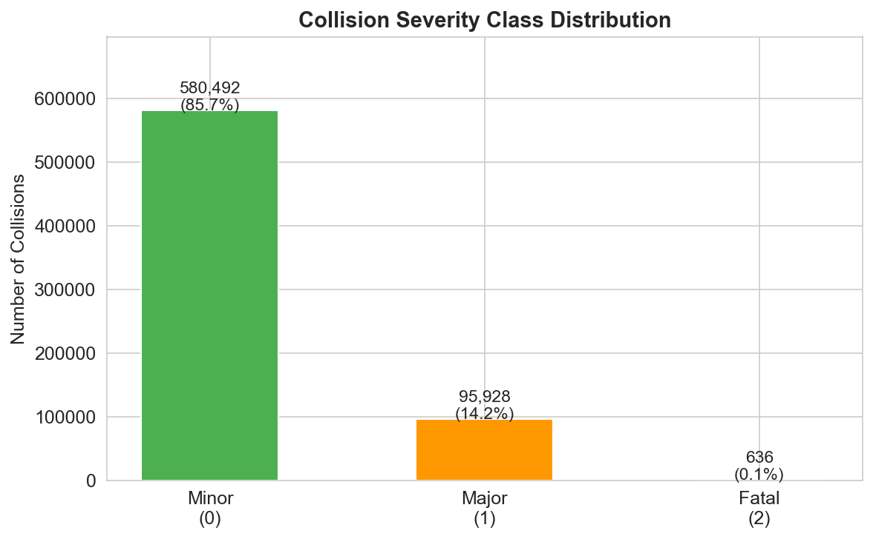
Figure 1: Collision Severity Class Distribution — Fatal collisions represent only 0.1% of all records

The bar chart above illustrates the severe class imbalance present in the dataset. Minor collisions dominate at 85.7% of all records, while Major injury collisions account for 14.2%. Fatal collisions represent a critically small minority at just 0.1%, or 636 records out of 677,056. This extreme imbalance directly motivates the use of SMOTE oversampling and the comparative balancing strategy analysis conducted in this project.

Data Preprocessing and Constraints
The following preprocessing steps were applied in order:
- Date Fix: OCC_DATE was stored as a Unix millisecond timestamp, requiring conversion to Toronto local time (UTC to America/Toronto) before merging with weather.
- GPS Cleaning: 131,978 records (16.3%) with latitude/longitude = 0.0 were removed as Not Spatially Available.
- Missing Values: FATALITIES NaN filled with 0; involvement flags (PEDESTRIAN, BICYCLE etc.) filled with NO; numeric weather columns filled with column median.
- Weather Flags: Wind speed and visibility were unavailable from the Toronto City station. Weather condition flags were derived numerically: is_rain (precipitation > 0.2mm), is_snow (precipitation > 0.2mm and temperature <= 2C), is_ice (temperature <= 0C and precipitation > 0.2mm).
- Encoding: Categorical columns (OCC_DOW, season, hour_category) were one-hot encoded. Neighbourhood (158 unique values) was frequency encoded.

Exploratory Data Analysis
Eight key visualizations were produced. Key findings from the EDA are summarised below. All plots are available in the GitHub repository.

Finding 1 - Severe Class Imbalance
The severity class distribution shows extreme imbalance: 85.7% Minor, 14.2% Major, and only 0.1% Fatal. This imbalance means that a naive model predicting Minor for every collision would achieve 85.7% accuracy while completely failing to identify any dangerous outcome. This finding directly motivates the use of SMOTE and the comparative balancing strategy analysis.

Finding 2 - Rush Hour Peaks
Collision frequency peaks clearly during morning rush hours (7-9 AM) and evening rush hours (4-7 PM) on weekdays, aligning with Toronto's known commuting patterns. Late-night hours (10 PM to 4 AM) show lower total collision counts but a disproportionately higher proportion of fatal and major outcomes, likely attributable to higher speeds, fatigue, and impaired driving.

Finding 3 - Seasonal Patterns
Winter months (December to February) and fall months show elevated collision frequencies, consistent with adverse road conditions including snow, ice, and reduced daylight. The season feature was engineered to capture this pattern systematically.

Finding 4 - Adverse Weather Impact
5.8% of collision-hours had rain (is_rain = 1), 2.0% had snow (is_snow = 1), and 1.2% had icy conditions (is_ice = 1). While the majority of collisions occur under normal weather (due to high exposure), the proportion of major and fatal outcomes is higher under adverse conditions, particularly snow and ice.

Finding 5 - Pedestrian Involvement
2.7% of collisions involve pedestrians and 1.8% involve cyclists. Despite being a small proportion, pedestrian-involved collisions show a dramatically higher rate of major and fatal outcomes, making pedestrian_involved one of the most important features in the predictive model as confirmed by SHAP analysis.
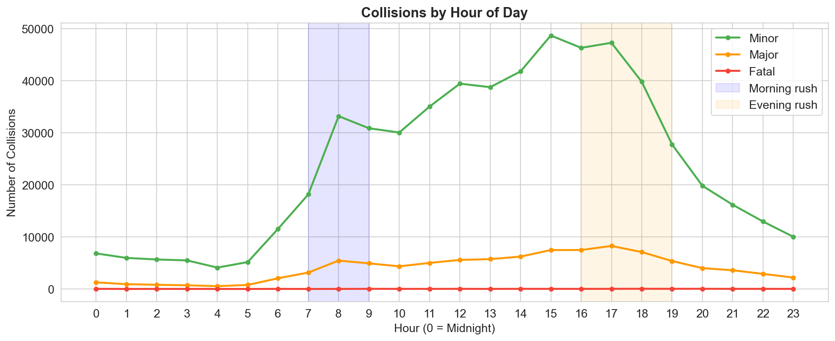
Figure 2: Collisions by Hour of Day — collision frequency by hour across severity classes

The line chart shows collision frequency broken down by hour of day for each severity class. Minor collisions show high counts during late-night hours (0 and 23), exceeding 200,000, then stabilise around 70,000 to 95,000 through the daytime hours. Major collisions peak at hours 0 and 23 at around 35,000 before dropping to 10,000 to 15,000 during daytime. Fatal collisions remain very low across all hours due to their small absolute count of 636. Late-night hours carry a disproportionately higher proportion of severe outcomes relative to total collisions, consistent with higher speeds and impaired driving risk during those periods.

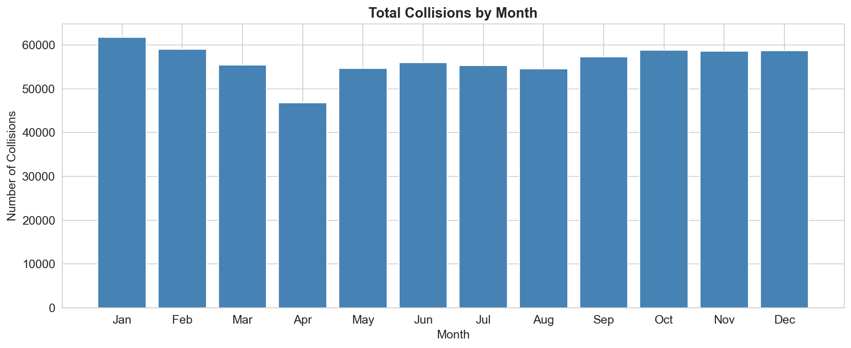
Figure 3: Total Collisions by Month — January peak and April low reflect seasonal conditions

The bar chart displays total collision counts across each calendar month. January records the highest collision frequency at approximately 62,000, followed by February and December, reflecting the impact of winter conditions including snow, ice, and reduced visibility. April shows the lowest count at approximately 47,000, reflecting improved spring road conditions. From May through December the counts remain relatively stable between 54,000 and 59,000, with no strong summer peak. This pattern confirms the value of including season as an engineered feature in the predictive model.

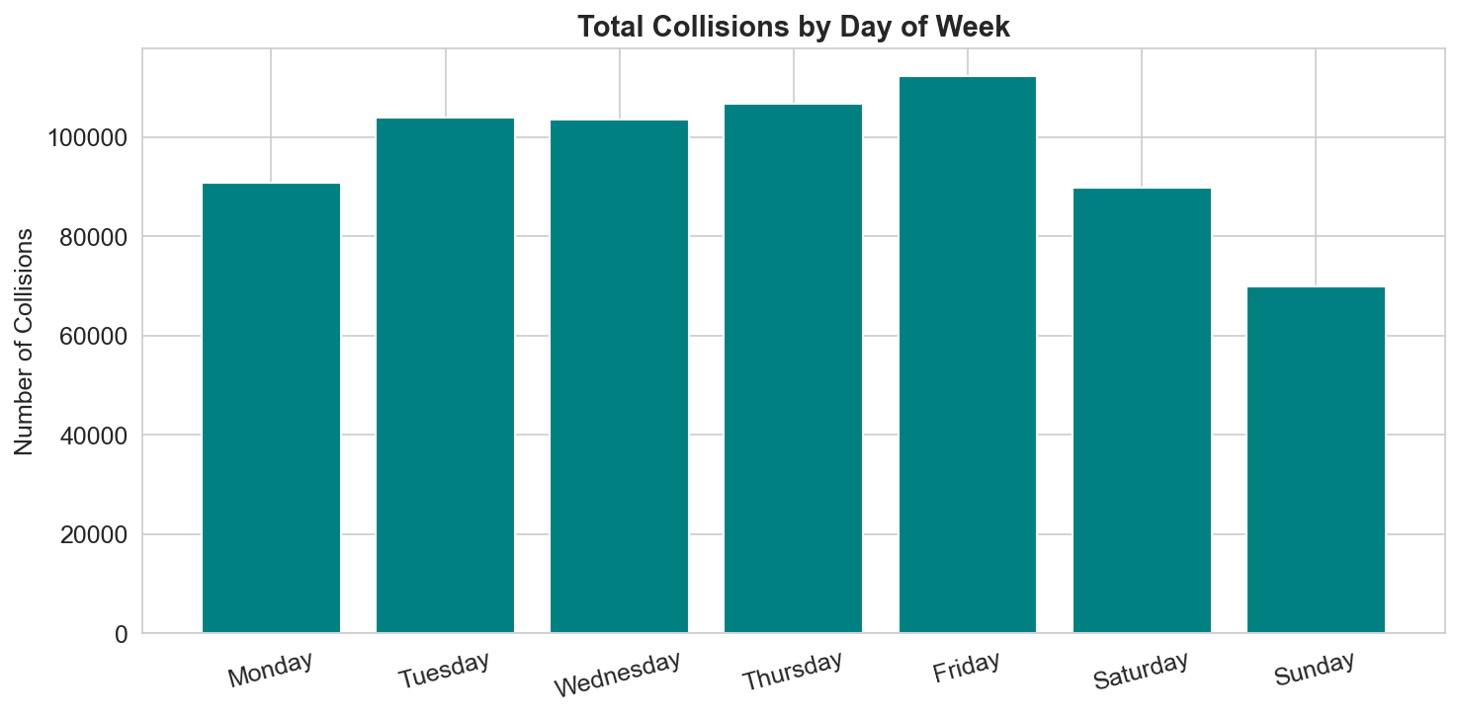
Figure 4: Total Collisions by Day of Week — Friday has the highest collision frequency

The bar chart reveals that Friday has the highest collision count across all seven days at approximately 112,000, while Sunday has the lowest at approximately 70,000. Weekdays Tuesday through Thursday show consistent counts around 103,000 to 106,000, while Monday and Saturday fall slightly lower at around 90,000 each. This pattern reflects higher weekday traffic volume combined with end-of-week driver fatigue on Fridays. Saturday collisions drop compared to weekdays as commuter traffic reduces, and Sunday shows the lowest volume of the week. The day-of-week variable was one-hot encoded and confirmed as a significant predictor in the SHAP analysis.
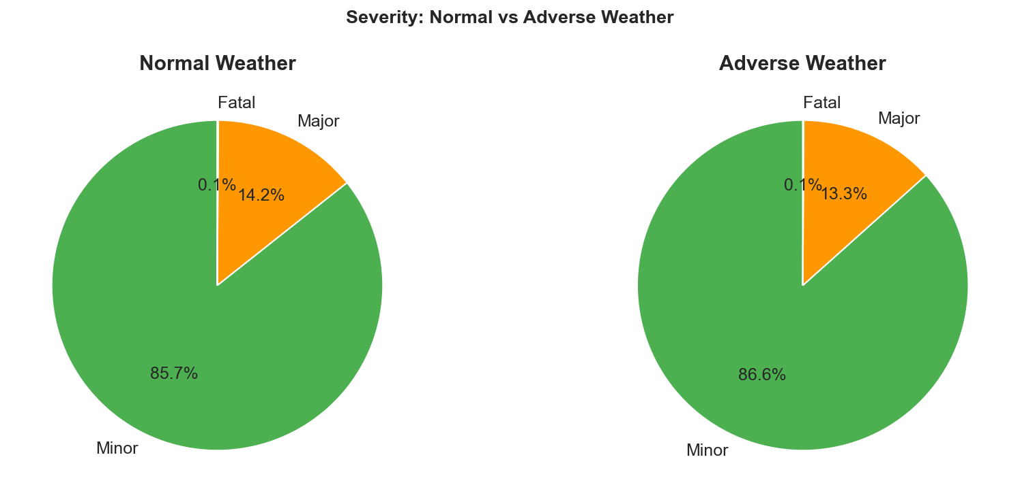

Figure 5: Severity Distribution under Normal vs Adverse Weather Conditions

The two pie charts compare severity distributions under normal weather versus adverse weather conditions including rain, snow, or ice. Under normal weather, Minor collisions account for 85.7% and Major for 14.2%. Under adverse weather, the Minor proportion increases slightly to 86.6% while Major decreases to 13.3%, with Fatal remaining at 0.1% in both cases. This counterintuitive pattern reflects the known risk compensation effect where drivers slow down and exercise greater caution during adverse conditions. Despite the proportional shift, the absolute number of adverse-weather collisions remains substantial, making weather flags important model predictors.

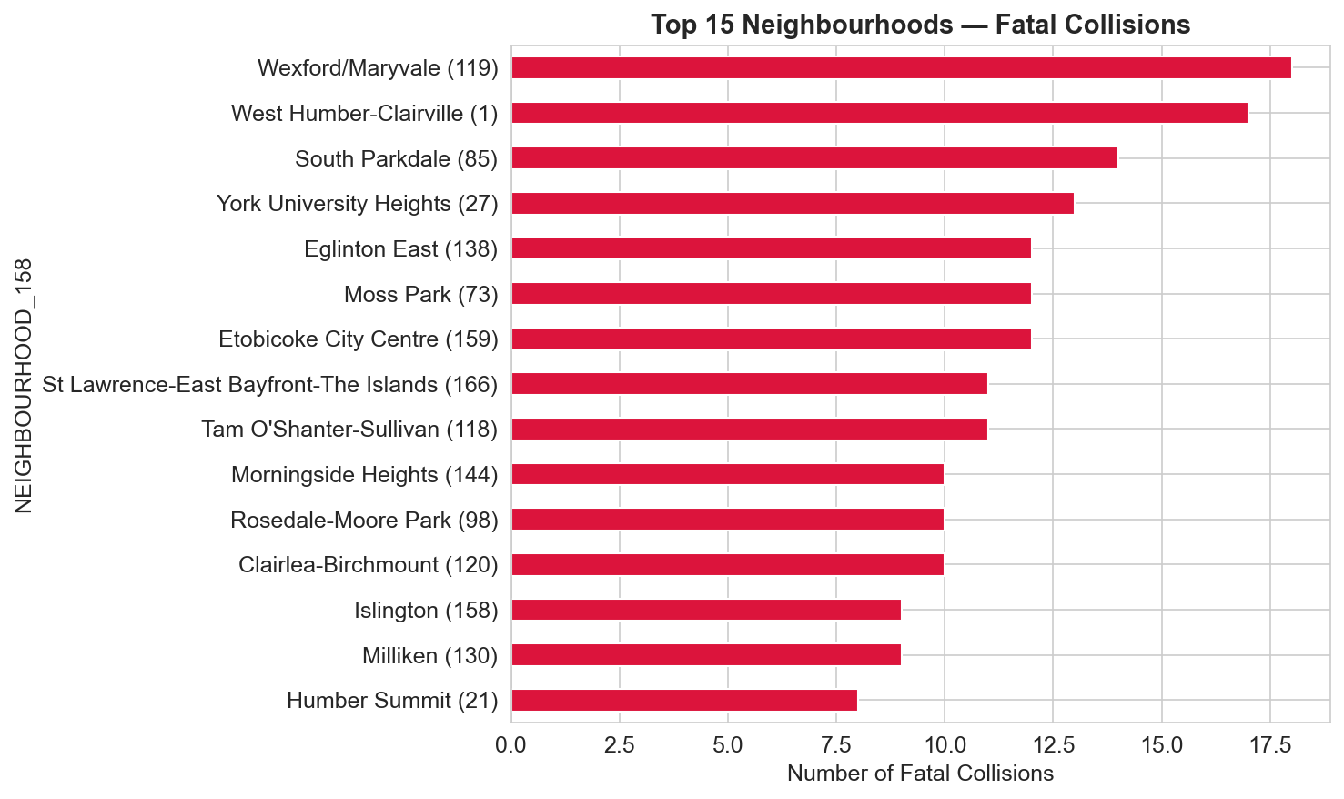
Figure 6: Top 15 Neighbourhoods by Fatal Collision Count — Wexford/Maryvale highest

The horizontal bar chart identifies the fifteen Toronto neighbourhoods with the highest number of fatal collisions over the study period. Wexford/Maryvale leads with 18 fatal collisions, followed by West Humber-Clairville with 17, South Parkdale with 14, and York University Heights with 13. Eglinton East, Moss Park, and Etobicoke City Centre each recorded 12 fatal collisions. These neighbourhoods share characteristics of high arterial road density and significant pedestrian exposure. Neighbourhood was frequency-encoded and confirmed by SHAP as one of the top four predictors of fatal collision outcomes.
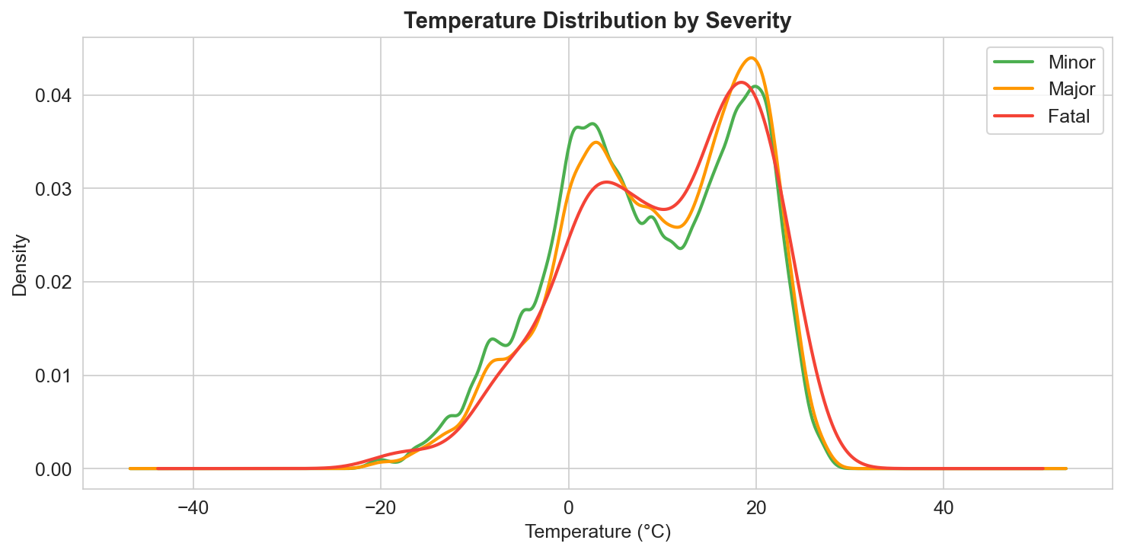
Figure 7: Temperature Distribution by Severity Class

The kernel density estimation plot compares the temperature distribution at the time of collision for each severity class. All three classes follow a broadly similar bimodal distribution with one peak around 0°C to 5°C and a larger peak around 20°C, reflecting Toronto's winter and summer seasons. The Fatal class (red) shows a notably higher density at the cold temperature peak relative to its warm peak, compared to the Minor and Major classes, suggesting a disproportionate share of fatal collisions occur during colder conditions. The Fatal line also extends further toward -40°C than the other classes, reinforcing the importance of temperature and season as predictive features.

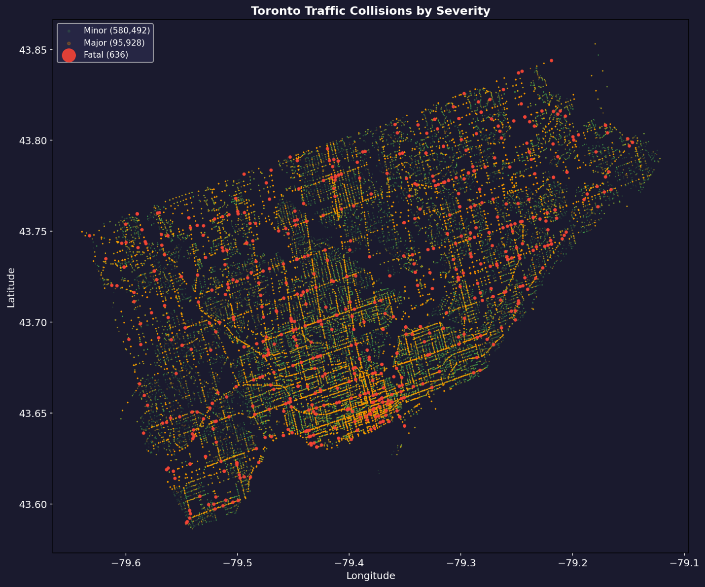
Figure 8: Toronto Traffic Collisions by Severity — road network visible from collision density

The static scatter map plots all 677,056 collision records across the Toronto road network, colour-coded by severity: Minor in green, Major in orange, and Fatal as larger red dots. The density of green and orange points effectively traces the city's major arterial roads and intersections without requiring a separate base map, clearly showing spatial concentration along downtown streets and major expressway corridors. Fatal collisions are distributed across the entire city but show visible clustering in the inner suburbs and along high-speed arterials. This spatial pattern was further analyzed using DBSCAN clustering which identified 36 distinct fatal collision hotspot zones.

Project Approach

Research Methodology
This research applies a five-phase supervised machine learning methodology. The framework integrates data from two publicly available sources, addresses class imbalance through comparative resampling strategies, trains and compares five classification algorithms, and applies SHAP explainability and DBSCAN spatial clustering to produce results that are both accurate and interpretable.

Phase 1 - Data Collection and Preparation
Toronto collision records (809,034 rows) were merged with hourly weather data from the Toronto City automatic weather station using a left join on aligned date-hour keys. The Unix millisecond timestamp in the collision dataset was converted to Toronto local time. The merge achieved a 100% match rate across all collision records.

Phase 2 - Data Cleaning and Feature Engineering
After cleaning, 677,056 valid records were retained. The target variable (severity) was derived as a three-class variable: Minor (0), Major (1), Fatal (2). Eight new features were engineered including hour_category, season, weather flags, involvement flags, and neighbourhood frequency encoding.

Phase 3 - Exploratory Data Analysis
Eight visualizations were produced to understand distributional patterns across temporal, spatial, and environmental dimensions. Key insights include rush hour peaks, seasonal trends, weather impact on severity proportions, and spatial concentration of fatalities.

Phase 4 - Model Training and Evaluation
The dataset was split 70/15/15 into training, validation, and test sets using stratified sampling. SMOTE was applied exclusively to the training set, creating 406,344 synthetic samples for each class (total training size: 1,219,032). Five models were trained and evaluated:
- Logistic Regression (baseline)
- Random Forest
- XGBoost
- Gradient Boosting Machines
- Multi-Layer Perceptron Neural Network
Five balancing strategies were additionally compared. Probability threshold analysis, RandomizedSearchCV hyperparameter tuning, and 5-fold stratified cross-validation were applied to strengthen the evaluation.

Phase 5 - Explainability and Geospatial Analysis
SHAP was applied to the best model (XGBoost) on a 2,000-record test sample to produce global feature importance, class-specific beeswarm plots, and per-collision waterfall explanations. DBSCAN clustering (eps = 300 metres, min_samples = 3) was applied to 636 fatal collision coordinates, identifying 36 hotspot zones.

Methodology Diagram
FIVE-PHASE PROJECT METHODOLOGY
↓
Phase 1 - Data Collection & Preparation
Toronto Collision CSV (809,034 rows) + Canada Climate Data (108,096 hourly rows)
Fix Unix timestamp | Merge on date+hour | Fix GPS coordinates
↓
Phase 2 - Data Cleaning & Feature Engineering
677,056 valid records | Target: Minor / Major / Fatal
New features: season, hour_category, weather flags, pedestrian_involved, neighbourhood_freq
↓
Phase 3 - Exploratory Data Analysis
8 visualizations: severity distribution, hourly/monthly patterns, weather vs severity,
correlation heatmap, neighbourhood fatals, temperature by severity
↓
Phase 4 - Model Training & Evaluation
5 models: Logistic Regression | Random Forest | XGBoost | Gradient Boosting | Neural Network
SMOTE | 5-strategy balancing | Threshold tuning | Hyperparameter tuning | 5-fold CV
↓
Phase 5 - SHAP Explainability & Geospatial Analysis
SHAP global + local explanations | Top 10 risk factors
Folium heatmaps | DBSCAN clustering (36 hotspot zones)
↓
Final Output
Trained Model | SHAP Risk Factor Report | Collision Hotspot Maps | Full Research Report
Figure 1: Five-Phase Project Methodology

Justification of Approach
Ensemble methods were selected based on consistent evidence in the literature that they outperform traditional statistical approaches for collision severity prediction (Chen & Wang, 2020; Parsa et al., 2020; Sheykhfard et al., 2021). XGBoost was specifically chosen as the primary model due to its demonstrated performance on imbalanced crash datasets (Parsa et al., 2020, AUC = 0.87). Logistic Regression was included as a baseline consistent with Al-Ghamdi (2002).
SMOTE was selected for class balancing following Parsa et al. (2020), with a comparative analysis of five strategies conducted in response to supervisor feedback. SHAP was selected over simpler feature importance methods based on Lundberg et al. (2020), who demonstrated its theoretical consistency and ability to produce both global and local explanations for tree-based models.
DBSCAN was preferred over K-Means for spatial clustering because it does not require a predefined number of clusters and correctly identifies noise points - isolated fatal collisions that do not form part of any hotspot zone - consistent with Xie and Yan (2008).

GitHub Repository
All project code, Jupyter notebooks, and output plots are available at the following GitHub repository:
Repository URL: https://github.com/Nishi-013/toronto-collision-severity-prediction
The repository contains five Jupyter notebooks corresponding to each project phase:
- 01_Data_Collection_Preparation.ipynb
- 02_Data_Cleaning_Feature_Engineering.ipynb
- 03_Exploratory_Data_Analysis.ipynb
- 04_Model_Training_Evaluation.ipynb
- 05_SHAP_Explainability_Geospatial.ipynb

References
Al-Ghamdi, A. S. (2002). Using logistic regression to estimate the influence of accident factors on accident severity. Accident Analysis & Prevention, 34(6), 729–741.
Chen, J., & Wang, L. (2020). Predicting traffic accident severity using machine learning: A review of classification approaches. Transportation Research Record, 2674(9), 1–12.
City of Toronto. (2024). Motor vehicle collisions involving killed or seriously injured persons. City of Toronto Open Data Portal. https://open.toronto.ca/catalogue/
Environment and Climate Change Canada. (2024). Historical climate data. Government of Canada. https://climate.weather.gc.ca/
Lundberg, S. M., Erion, G., Chen, H., DeGrave, A., Prutkin, J. M., Nair, B., & Lee, S. I. (2020). From local explanations to global understanding with explainable AI for trees. Nature Machine Intelligence, 2(1), 56–67.
Parsa, A. B., Movahedi, A., Taghipour, H., Derrible, S., & Mohammadian, A. K. (2020). Toward safer highways, application of XGBoost and SHAP for real-time accident detection and feature analysis. Accident Analysis & Prevention, 136, 105405.
Rezapour, M., Molan, A. M., & Ksaibati, K. (2020). Analyzing injury severity of motorcycle at-fault crashes using machine learning techniques, decision tree and logistic regression models. International Journal of Transportation Science and Technology, 9(2), 89–99.
Sameen, M. I., & Pradhan, B. (2017). Severity prediction of traffic accidents with recurrent neural networks. Applied Sciences, 7(6), 476.
Sheykhfard, A., Haghighi, F., Nordfjærn, T., & Soltaninejad, M. (2021). Logistic regression models for rural and urban crashes on two-lane two-way roads: A case study from Iran. IATSS Research, 45(1), 107–114.
Xie, Z., & Yan, J. (2008). Kernel density estimation of traffic accidents in a network space. Computers, Environment and Urban Systems, 32(5), 396–406.

